1. Displaying the student home page

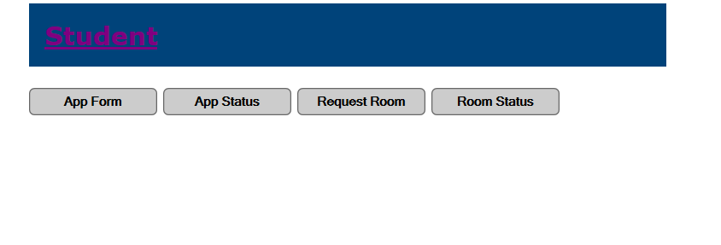

1. Student may select the appform to complete a form to submit their residency application

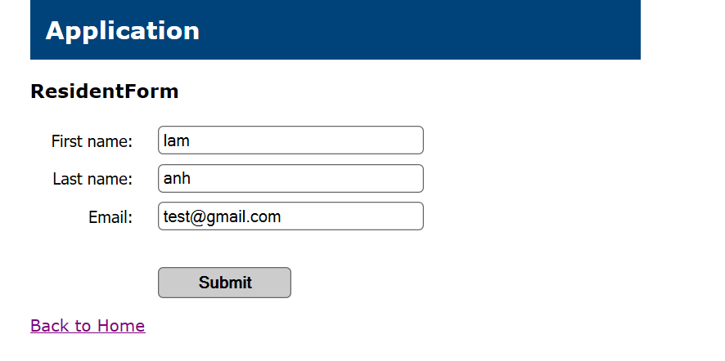

1. Once form has been filled and submitted

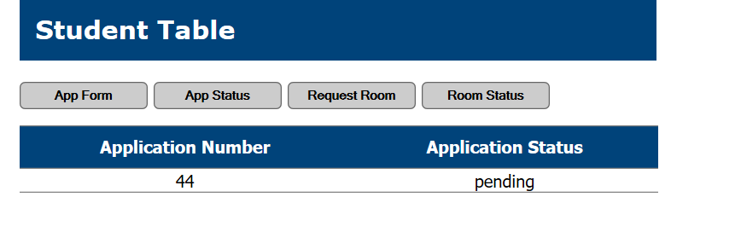

1. Student will wait for application status to change once approved by an administrator
2. On admin home page

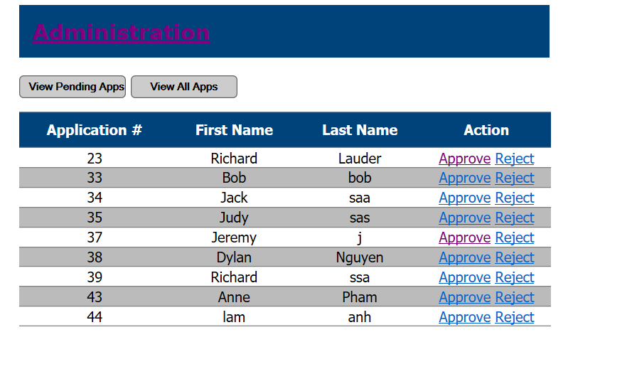

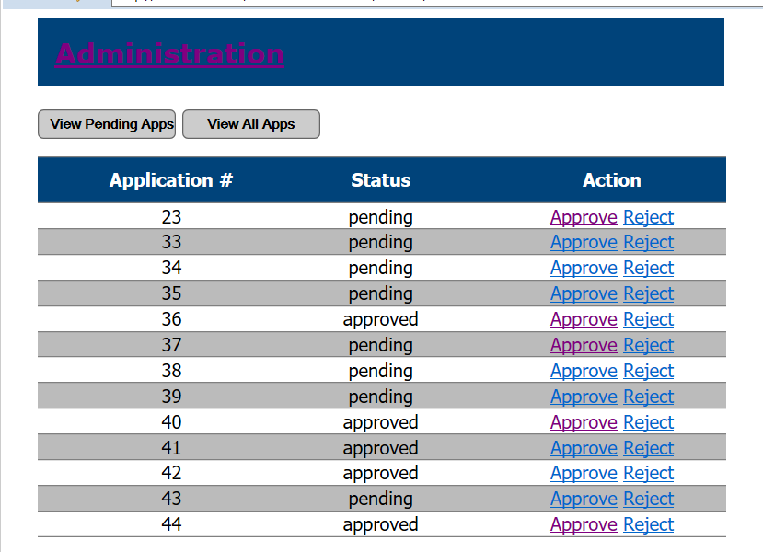

1. List of all pending applications admin can select application 44 to approve. The field will disappear after being approved. It can be viewed in all apps with all application status approved rejected or pending.
2. The student may see their status changed to approved
3. 